Order Of Service

Singing: Psalm 139b—CW page 117

Reading: Psalm 74

Opening Hymn: CW 260

Reading: Philippians 4

Request Hymn: CW Supplement 754

Reading: Mark 14:26-31

Sermon Hymn: CW 138

Sermon Text: Luke 23:26

Simon A Syrenian

Prayer

The Apostles’ Creed, TLH page 12

Holy Communion

The Lord's Prayer

The Blessing

Closing Hymn: CW 619

************

Koinonia Hour

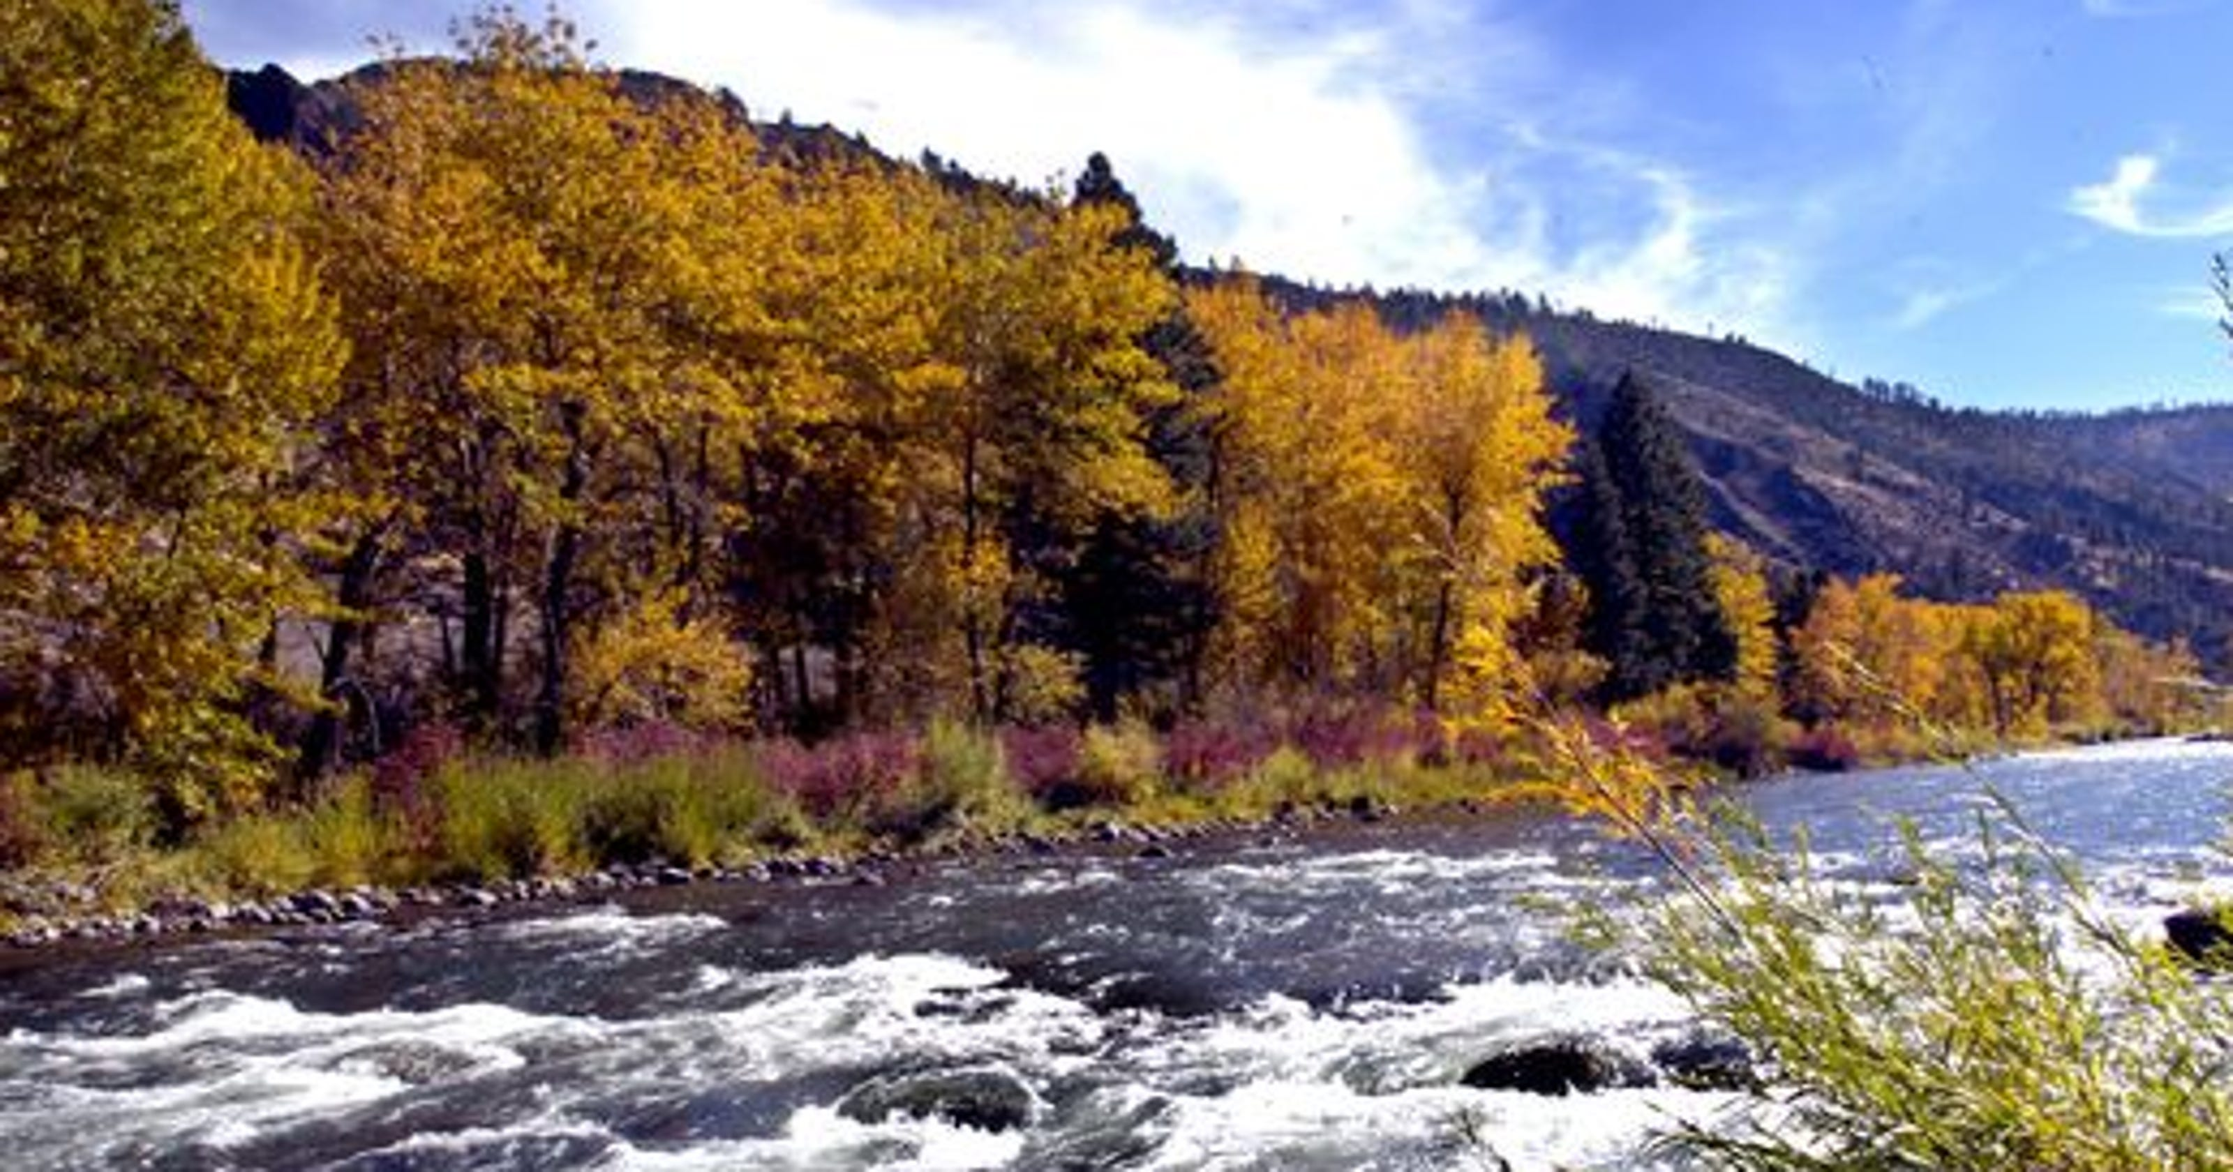

Fall In Nevada

Water
Of
Life
3 September 2023

W A T E R O F L I F E

Independent Christian Church—Conservative Lutheran Doctrine

Worship Service: 9:30 a.m.

Larry Cooper, Pastor E-Mail address:
lcooper@wateroflife.cc
Web Site:
www.wateroflife.cc

* * * * * * * * * * * * * * * * * * * * * * * * * * *

Sermon Text: Luke 23:26

Simon A Cyrenian

* * * * * * * * * * * * * * * * * * * * * * * * * * *

26 And as they led him away, they laid hold upon one Simon, a Cyrenian, coming out of the country, and on him they laid the cross, that he might bear it after Jesus.



